# **SIST CGPA**

# **CGPA Calculator for Sathyabama Students**

## **Problem Statement**

Many students at Sathyabama University face challenges in calculating their Cumulative Grade Point Average (CGPA) accurately and efficiently. The current process requires manual entry of marks from different semesters, which is time-consuming and prone to errors. Moreover, students need a reliable tool to track their academic performance regularly and make informed decisions about their studies.

## **How It Works**

SIST CGPA is an innovative app designed to simplify the process of calculating CGPA for students of Sathyabama University. By leveraging the university's ERP system, the app automatically retrieves students' semester marks and calculates their CGPA with precision. Additionally, students can manually enter their subjects and marks if they prefer not to log in.

### **Key Features**

1. **ERP Integration**: The app connects seamlessly with the university's ERP system. Students can log in using their ERP credentials to access their academic records.
2. **Automatic Data Retrieval**: Once logged in, the app fetches the students' semester marks directly from the ERP portal. This eliminates the need for manual data entry, ensuring accuracy and saving time.
3. **Manual Entry Option**: For students who prefer not to log in or need to enter marks for specific subjects manually, the app provides an option to add subjects and marks without logging in.
4. **CGPA Calculation**: The app uses the official CGPA calculation formula to compute the cumulative grade point average based on the retrieved or manually entered marks.
5. **User-Friendly Interface**: The app features an intuitive interface that is easy to navigate. Students can view their CGPA, individual semester GPAs, and detailed mark sheets in a clear and organized manner.

## 

## **Screenshots**

Login and get marks from ERP and getting the CGPA

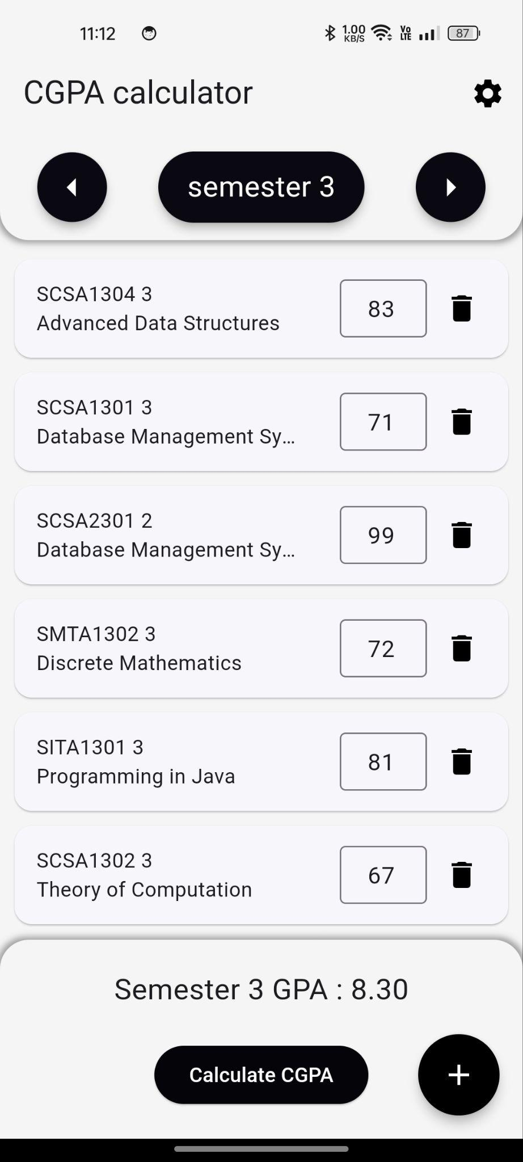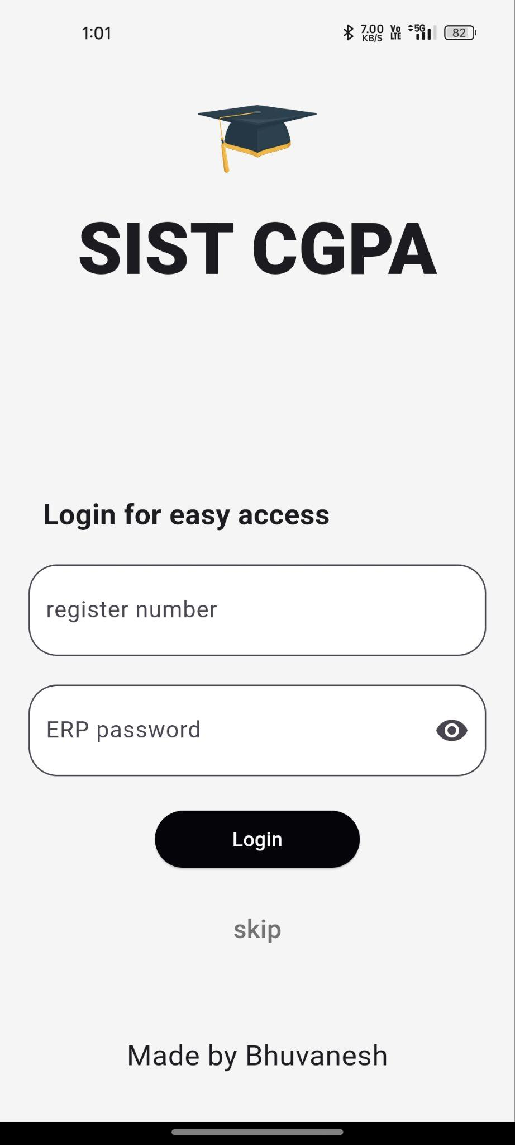

Entering marks manually and adding custom subjects